PRESS RELEASE Cambridge, UK - 1 August 2014
Laser Beam Products Steps Up Custom Lapping & Polishing Services For Extreme Precision
Laser Beam Products, the leading manufacturer of metal laser optics, has seen recent growth in its precision lapping and polishing services, catering for more customers with their ability to produce flaw free, ultra smooth precision surfaces.
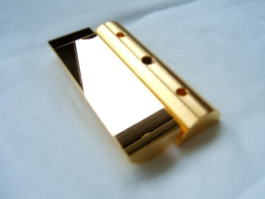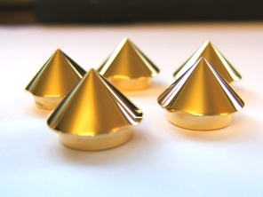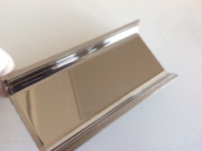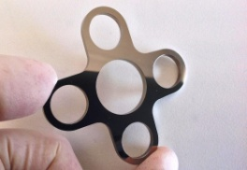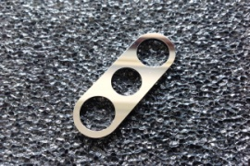
Mark Wilkinson, LBP Managing Director explains, “Over the last 25 years we’ve lapped and polished many different materials using our unique chemical polishing techniques. We can produce highly accurate parts with ultra smooth surfaces of sub micron flatness and parallelism. A mirror quality surface finish is possible on many ferrous and non ferrous metals, we also have our own Electroless Nickel and Electroless Gold coating plant. Outside of our core laser mirror market, this service has many other applications including parts used in alignment and positioning systems, test equipment, gas seals, valve seats, Formula 1 and scientific instruments.”
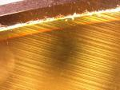 This photo shows clearly the surface roughness of a diamond machined mirror that results in scatter and diffraction.
LBP have known for many years that the ultra smooth surfaces achieved on their mirrors are much better than those achieved by diamond machining, which can leave surfaces with cutting arcs, target patterns or chatter marks. These machining artifacts can cause problems with camera systems and visual alignment where scattered and diffracted light hinders machine vision and monitoring systems. The same applies to customers who require optical precision for non-laser applications - LBP can provide sub micron flatness, sub arc minute parallelism and Angstrom levels of surface roughness.
‘We’re helping more and more customers who have a need for extreme precision. We can polish many different materials so if customers aren’t sure, all they need to do is call and ask, we love a challenge!’ comments Mark.
For more information you can visit the LBP website www.lbp.co.uk email sales@lbp.co.uk or call +44 (0)1767 600877
- ENDS -
About the company
Laser Beam Products (LBP) is a leading manufacturer of laser mirrors and infrared optics, founded in 1990 near Cambridge in England and exporting worldwide. Laser Beam Products is particularly well known for metal CO₂ laser mirrors and gold coated copper mirrors.
LBP has the ability to provide a wide range of precision mirrors for many diverse applications. The company has developed new laser mirror designs and improved specifications of laser mirrors across the whole spectrum to keep ahead of laser and electro optical technological advances. LBP supply mirrors for deep UV through to THz use as well as scientific mirrors for chemical sensing, instrumentation, spectroscopy and imaging.
LBP have adopted lean manufacturing practices, guided by the University of Cambridge, and the company is a long-term member of the Association of Industrial Laser Users (AILU).

